**Question:** Assume that you’re the Network administrator for the ABC company and construct the routing table using static routing. The company has three networks with three routers(PT-Router), three switches(2950T-24) and each switch contains four end PC’s. Along with this company manager asked to configure the present time and date, want to display the interfaces.

1. Change the name of PC’s as CCE1,CCE2, CCE3 and CCE4 for one network, COM1, COM2, COM3 and COM4 for second network and for another network as IST1, IST2, IST3 and IST4.

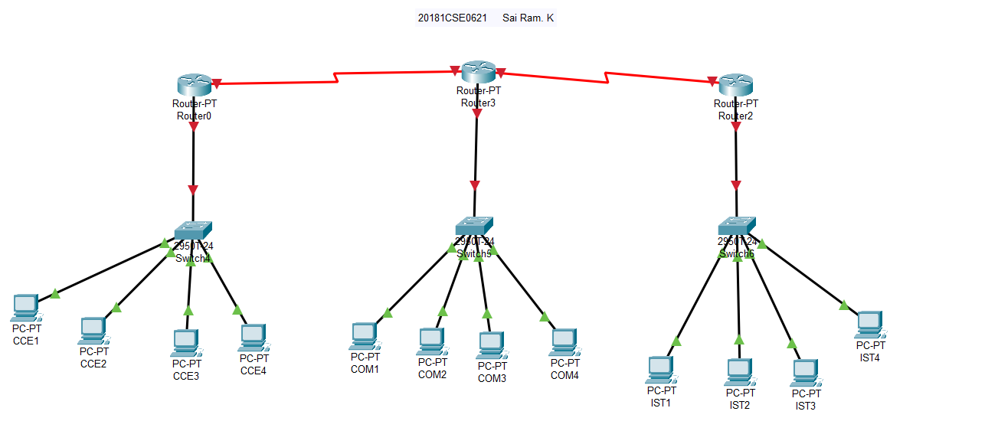

1. Configure the PC’s and routers

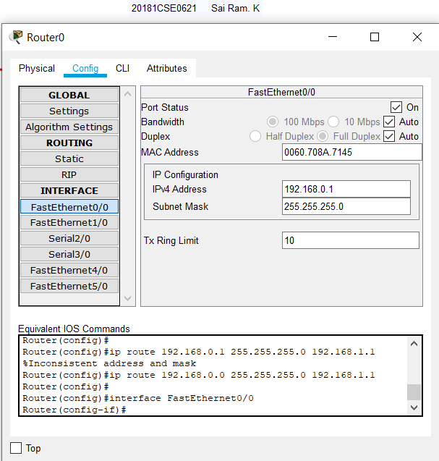

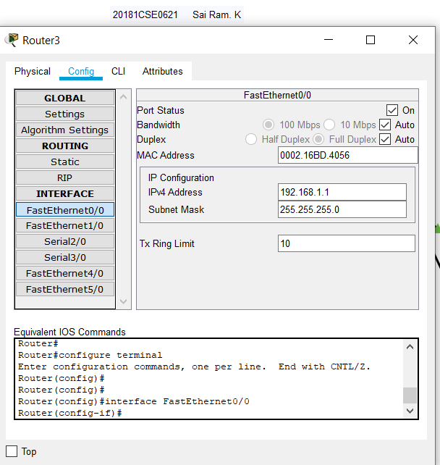

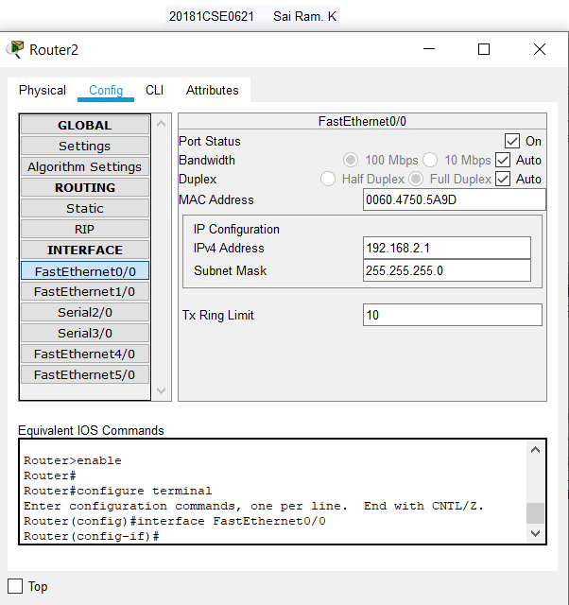

1. As a network administrator, add entries into a routing table manually for all the routers with the proper network interfaces

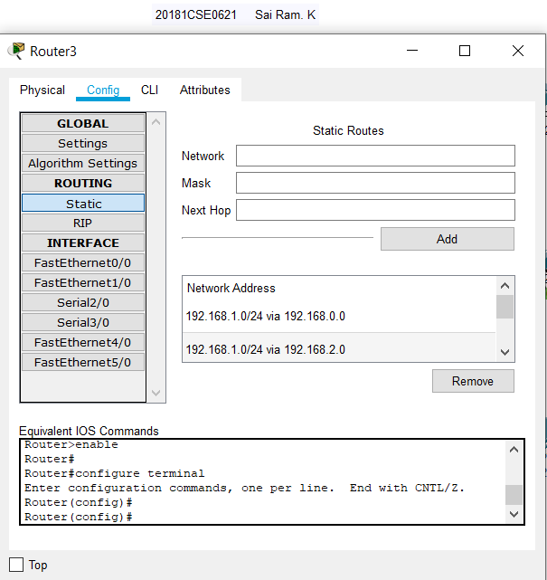

1. Send the packets between two networks

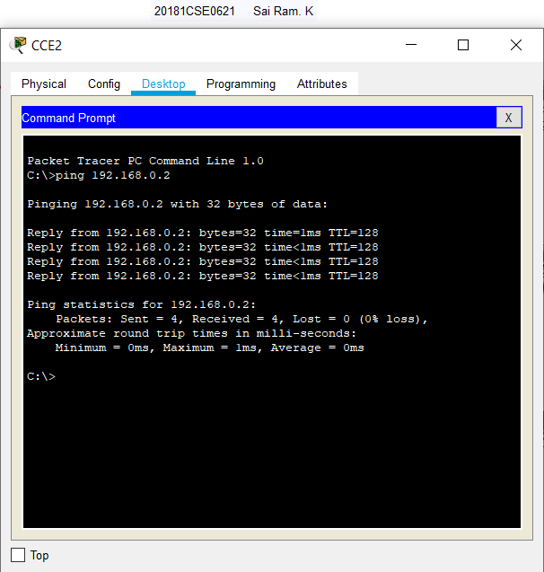

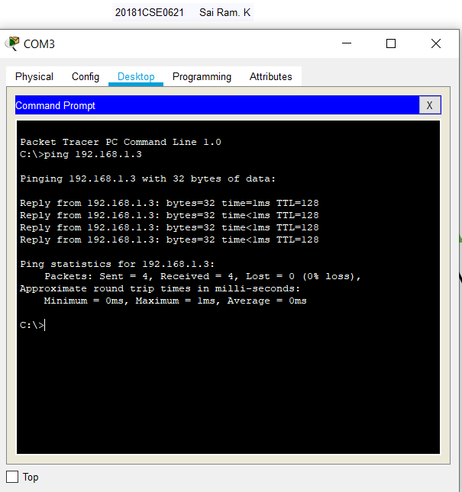

1. Configure the clock with present date and time

Switch 1.

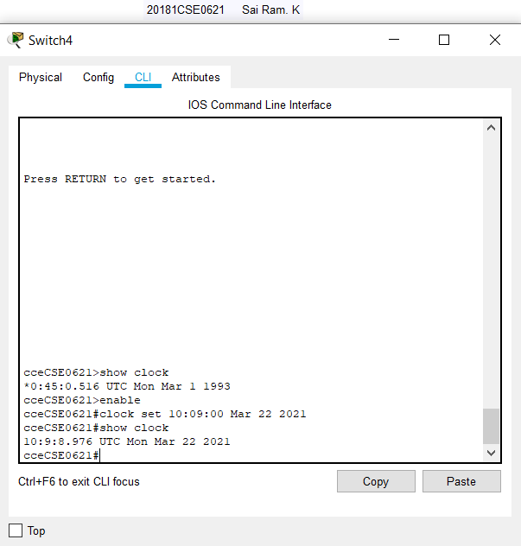

Switch 2.

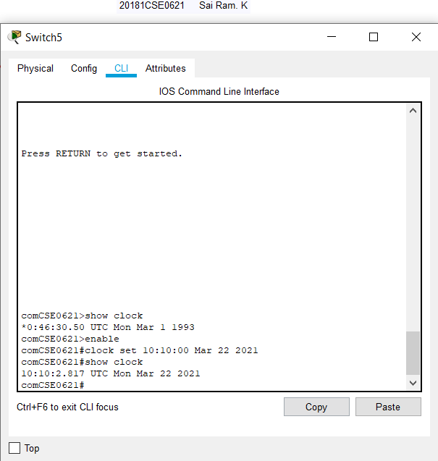

Switch 3.

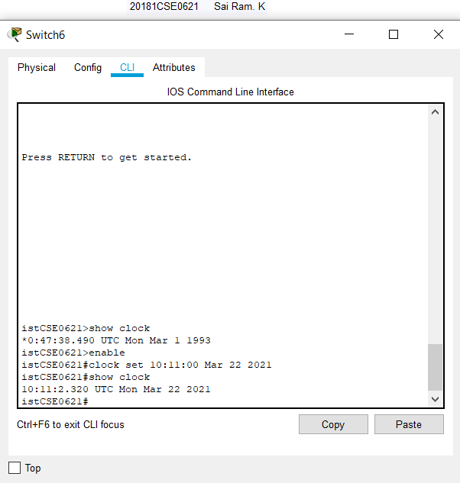

1. Set the hostname of three switches as CCE, COM and IST followed by Rollno

Switch 1.

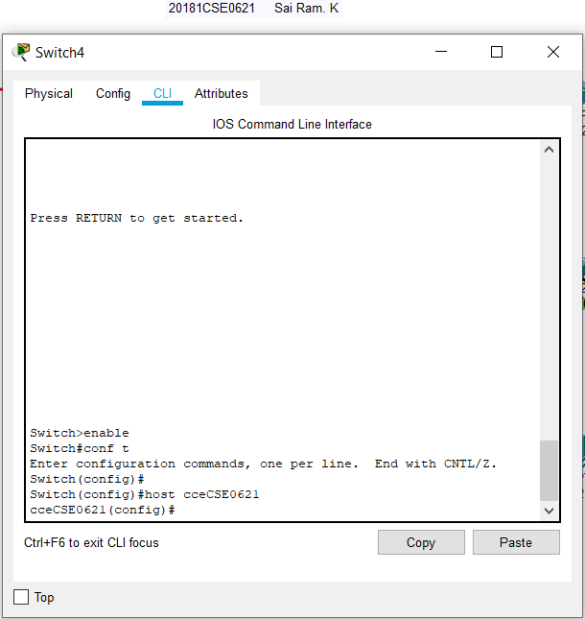

Switch 2.

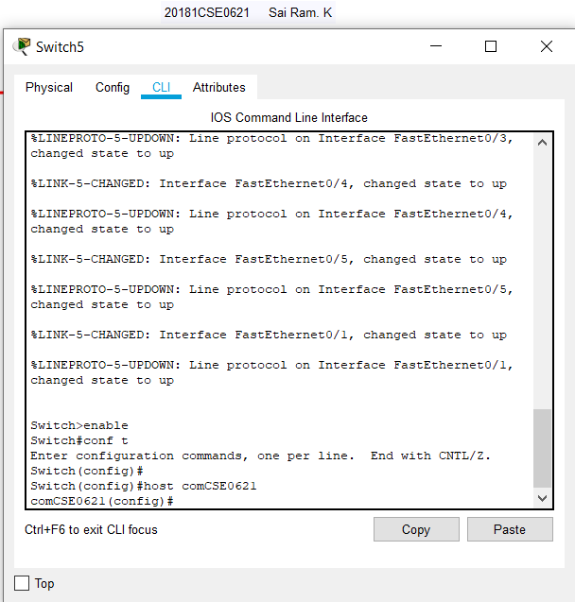

Switch 3.

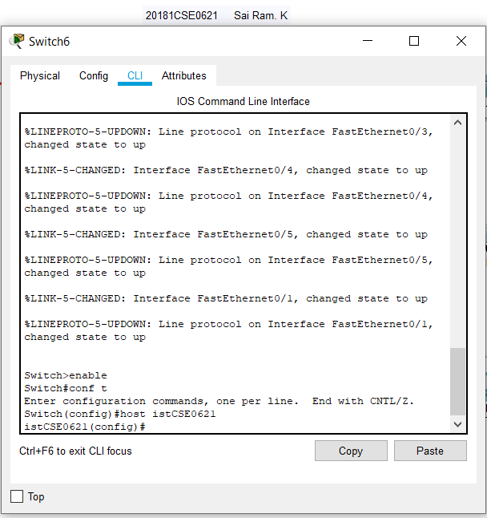

1. Show the interfaces information for all the PC’s

Switch 2.

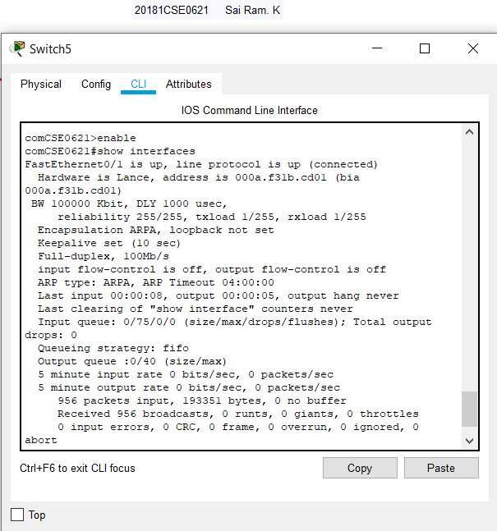

Switch 1.

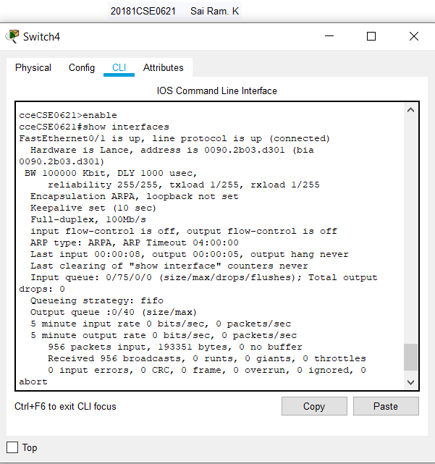

Switch 3.

